CHILDREN MOVEMENT FOR CLIMATE JUSTICE (CMCJ) STATE LEVEL CONSULTATION MEETING
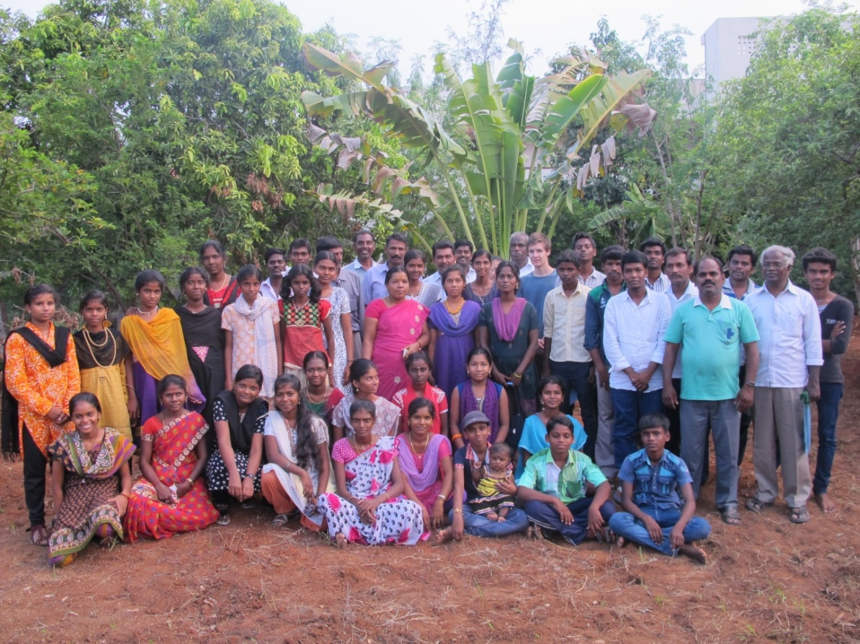

DATE: 3 & 4TH October 2014 VENUE: MADURAI

REPORT PREPARED BY:
Master Jone, State Coordinator
Mrs. Panchavarnam, Member of CMCJ
REPORT TRANSLATED BY:
Mr. Nirmal Raja, State Convenor
Ms. Y. Kumutha, Assistant Project Officer

CHILDREN MOVEMENT FOR CLIMATE JUSTICE (CMCJ) STATE LEVEL CONSULTATION MEETING
DATE: 3 & 4TH October 2014 VENUE: MADURAI
Introduction
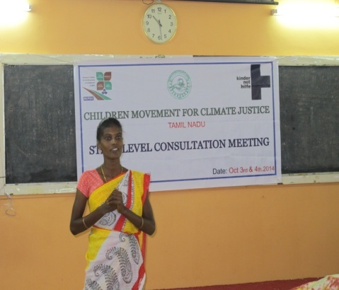
The state level consultation meeting was organized by RCPDS and CMCJ in Madurai on 3rd and 4th of October 2014. About 60 Children and staff from the TN CMCJ groups of various organisations like SASY, CCRD, RCPDS, SPEECH etc., participated in the consultation meeting. The participants were elected by the members of CMCJ and they will stand as State Level Committee. The main content of the meeting focussed on State and National level committee, membership database compilation and website designing, Action Plan for next 2 years was decided by the CMCJ participants. The overall meeting was facilitated by Mr. Jone, State Co-ordinator and Mr. Nirmal Raja, State Convenor of CMCJ
Purpose
The purpose of the meeting was shared by Master Jone, State Coordinator of CMCJ. It is to share the vision, discuss its structure and prepare the future plan for next 2 years. CMCJ being a national movement a state plan of action is very necessary to be prepared for the execution of the project. A welcome song was sung by one of the CMCJ member Master Isaiarasan from SASY followed by Ms. Panchavarnam from RCPDS delivered welcome address.
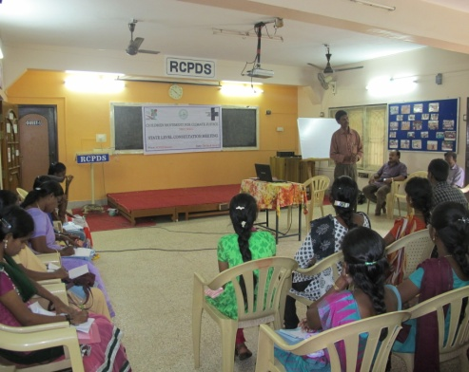
Background of CMCJ and Action Plan for CMCJ
Mr. Nirmal Raja, State Convenor of CMCJ shared the background of Children Movement for Climate Justice, started in the year 2008 with the help of RCPDS in Virudhunagar District with 30 children. Now, CMCJ extended to seven States called Tamilnadu, Karnataka, Andra Pradesh, Maharashtra, Odisha, Bihar, and Jharkhand with 15,000 members.
Children Movement for Climate Justice Program facilitated and supported by KNH, Germany. CMCJ accepted by KNH as official partner with partner ID number 2022. CMCJ project no is 21730. KNH provided financial support for carry out CMCJ activities at State and National Level for the period of September 2015 to August 2016. He summarised the highlights of earlier Odisha and Chennai meeting, Yatra from Kanniyakumari to Chennai and decision taken during the meeting. He also briefed about the overall content of this consultation meeting.
Session1: CMCJ membership Database compilation and Website Designing
Master Jone, State Coordinator of CMCJ and Mr. Dennyson James, Administrative Officer of RCPDS elaborated the CMCJ membership database, about its working, importance of database. CMCJ members clarified their doubts with Mr. Dennyson James and they also suggested some ideas like creating social network for CMCJ group members so they can see their program activities based on which the viewers will give comments and suggestions. It will be rectified in future activities. Master Jone, State coordinator of CMCJ requested the participants to send their program activities related to CMCJ to the following email Id’s cmcjtn@gmail.com, rcpdsknp@gmail.com for State Convenor office, cmcjindia@gmail.com for national convenor office, which helps to circulate the CMCJ activities among other members at National Level.
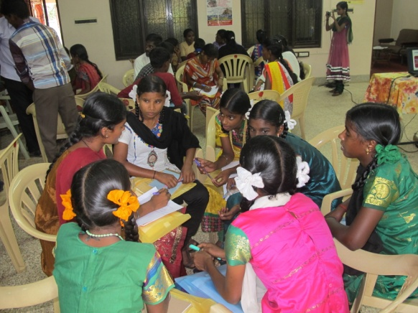
Technical Session I: Objective of the Session (facilitated by Mr. Jone, State Coordinator, Mrs. Panchavarnam from RCPDS and Mr. Joseph Edmund from CCRD):
The children participants were made in to 11 working groups and provided with chart papers to write down the guidance and assistance required from State Convenor and State Coordinator during activities accomplish at organisation level.
The children came out with the following suggestion:
-ID card for CMCJ members
-Reports to be shared among partner NGOs
-Updating current issues related to climate justice and climate change
-Public Boards to be set up on Climate change
-Training to be given on reporting requirements
-Exposure Visit
-Cultural training
- Networking with Government departments
- Organisation visit to be conducted once in three months
- Accounts to be submitted to the State level committee at the end of the year
- Visit date to be informed in prior

REPORTING AND DOCUMENTATION at Partner Level
- Mr. Nirmal, State Convenor and Master Jone explained the records maintenance at the respective organisational level for reporting and documentation purpose. Finally each group came out with the following suggestion
    - Each and Every partner organisation should maintain monthly meeting minutes book at Organisation level
    - Partner Organisation should maintain CMCJ Membership list up to date.
    - Keep Special event / activity register at Organisation where participants details, no of participant, venue, title of the project, Guest Name, Brief about the training or activity to be mentioned.
    - Partner organisation should keep common reporting format for all.
Session 2: Introduction to State and National Level Structure
Master Jone, State Coordinator, Mr. Nirmal Raja, State Convenor of CMCJ evoked the decision taken during Consultation meeting held at Odisha.
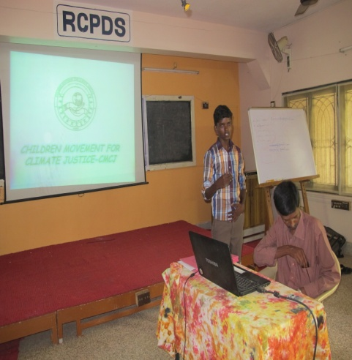
- Why the CMCJ Movement
- What is the Movement about
- How to take the Movement and
- For Whom the Movement is.
The decisions are
1. CMCJ should have a policy framework at national level
2. State and National Level Structure for CMCJ
State Level Structure
Master Jone, State Coordinator of CMCJ explained about the State and National Level Structure of CMCJ. From each partner organization three elected members will represent at the State Level Committee thus a total of 35 which includes Office Barrers-3, Executive Commitee-12, and subcommittee- 4 (Capacity Building, Advocacy and lobbying etc.,) which consist of five members in each committee. Three members from each State Level Committee will be present in the national level committee. He also explained the duties of each committee members.
State Level Structure

National Level Structure
Each state represented by 3 members then the National Committee will have 21 (3*7) members includes office barrers-3, executive committee-4 and general body-14. It was suggested that the minimum age for becoming member of the movement should be 13 and maximum 18. But there are some CMCJ members who have crossed 18, they can continue as member till they are 25. Mr. Nirmal Raja and Master Jone clarified the participant’s doubts.

National Level Structure
Technical Session-II: State level action plan for the period of January 2015 to March 2016
Objective of the Session shared by Master Jone, State Coordinator (Mr. Isaiarasan from SASY, Mr. Shine from RCPDS and Mr. Joseph Edmund from CCRD):
The children participants were made in to 3 working groups and provided with chart papers to write down the CMCJ action plan for State level from January 2015 to March 2016. Each group representatives were asked to present their action plan to accomplish the project activity. Mr. Jone, State Coordinator consolidated the action plan for the next year at State level
- Conference/workshop on Climate Change vs Child Rights to be conducted twice in a year
- Awareness program to be conducted at various levels to state level
- 1, 00,000 Tree Plantation to be done
- Rally to be conducted twice in a year
- Signature campaign to be performed to urge the government to take decision on climate change
- State level Cultural yatra to be conducted once in a year
- Capacity Training program to be conducted on the following topics like Communication, Reporting and Documentation

Cultural Program for Children
To bring a break from the long exercises, a cultural program was organized for the children where children got the opportunity to express their talents. Mr. Isaiarasan from SASY, Mr. Shine from RCPDS and Mr. Joseph Edmund from CCRD facilitated the cultural program. On the program, Comedy show by CCRD, Dance, and awareness song were performed. Children were happily enjoyed the cultural event with their friends.
The day-1 session then ended up with the above exercise.
Day-II - Session-I
The second day program started with recap session of previous day program with Prayer. Mr. Erskine, Project Director of SPEECH explained about the following concepts
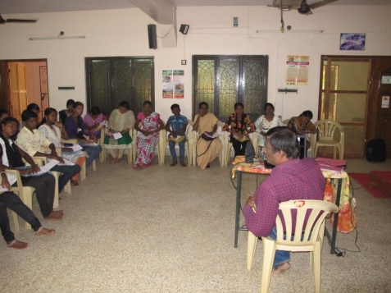
- Need for Child Protection Policy in National, State, Panchayat and School level
- Four Basic Rights of the children
- 3R’s- Roles, Responsibility, Rights
- Ensuring Child Rights and Protection
- Factors influencing child rights violations
- Policy linkages with MDGs
- Code of conduct
Mr. Nirmal Raja, State Convenor and Master Jone spoke about the importance of CMCJ child protection policy at National level
Technical Session- III- The participants were in made in to 3 working groups and asked to write down the scope of child protection policy, objective, code of conduct, do’s and don’ts, procedure for addressing child rights violation issues. Mr. Jone, State Coordinator guided the Groups to Prepare CPP. Each group came out with the following results
Outcome from the participants:
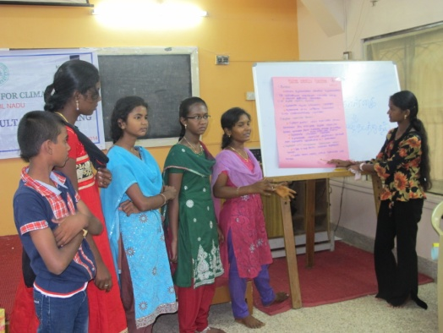
Who are Children?
  - 0-18 years of age

What are the Problems faced by children:
  - Sexual Abuse
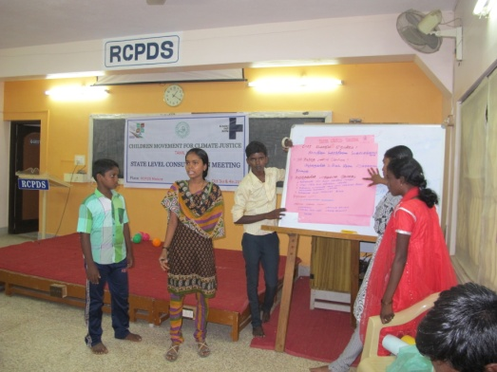
  - Corporal punishments
  - Children related issues like early marriage, child marriage, Verbal abuse etc.,

Code of conduct:
  - Respect the privacy and dignity of each and every child.
  - Be visible while in contact with children at the work place.
  - Ensure that children to interact and express their issues
  - Respect and encourage children’s voices and views.
- Ensure children’s participation in terms of taking decisions
Don’t’s
- physical, verbal, emotional abuse
- Actions or visual displays
- Harassment, Discrimination

For addressing these issues
- Complaint box should be kept in common places
- A Special Committee should be formed to address the problems related to child issues
- Special Committee will consist of 5 members comprising of 1 chairperson, 2 CMCJ members and 2 staff of CMCJ
- Special Committee will enquire and take decision on the complaint matter
- Special Committee members should act neutral without any bias during enquiring the matter
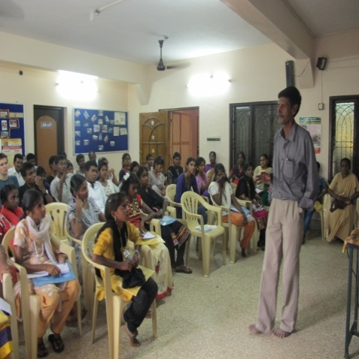
Session III: Optional Protocol 3:
Mr. Nirmal, State Convenor, Master Jone, State coordinator explained about Optional Protocol 3 (OP3), enquiry procedure, Timeline of OP3 and key features of OP3. OP refers to Optional Protocol to the UNCRC
- The Optional Protocol to the CRC on the Involvement of Children in Armed Conflict (OPAC)
- The Optional Protocol to the CRC on the Sale of Children, Child Prostitution and Child Pornography (OPSC).
The Third Optional Protocol to the CRC on a Communications Procedure (OP3 CRC) is the treaty which establishes an international complaints procedure for violations of child rights.
OP3 CRC provides two new ways for children to challenge violations of their rights committed by States:
- A communication procedure, which enables children to bring complaints about violations of their rights to the UN Committee on the Rights of the Child, if they have not been fully resolved in national courts
- An inquiry procedure for grave and systematic violations of child rights
Enquiry Procedure (Art. 13 OP3 CRC):
- Anyone can send information to the Committee alleging grave or systematic violations of children’s rights.
- No link with a direct victim of a violation is needed.
- Where needed and with the consent of the State party, the inquiry may also include a visit to its territory by Committee members.
Key Features of OP3:
- OP3 CRC is the only complaints mechanism to cover the full range of children ’s rights
- OP3 CRC helps ensure that children have effective remedies available to redress violations
- OP3 CRC helps strengthen the effective implementation of the CRC and the accountability of States parties
- By ratifying OP3 CRC, States reaffirm that children are full right holders and allow them to seek a remedy at the international level, if violations of their rights could not be solved at National level.
Technical session II: The objective of the session shared by Master Jone, State Coordinator of CMCJ. The participants were made into 3 working groups and they were asked to write down the measures to be taken for urging the government to sign on OP3. The groups were facilitated by Ms. Gayathri from SASY, Ms. Amutha from RCPDS and Ms. Lavanya from SPEECH. The group came out with the following measures/action for urging the government to sign on OP3
Working Group Presentation:
- Signature Campaign to be conducted in order to create awareness among youths and children on OP3
- Advocacy and Lobbying on OP3
- Rally and Campaign on OP3 to be conducted
- Missed call alert (Toll free number) for seeking support from Indian citizen to urge Indian government to sign on OP3
- VIP’s involvement in terms of creating awareness on OP3 among public
- Submitting petition to the State Government
- Cultural Program/ Yatra to be conducted
- Urging State government to compel Indian Government to sign on OP3
CONSOLIDATION SESSION
Master Jone, State Coordinator and Mr. Nirmal Raja, State Convenor has summarized the 2 day consultation meeting and conclusion. The following decisions are taken during the consultation
- Partner organisations will send names of representatives (in case if change) to the State convenors office
- Each and Every partner organisation should maintain the following records
  - Meeting Minutes Register at organisation level
  - Maintaining CMCJ membership list book
  - Special Event Register
- Monthly activities report at organisational level should be send to State Convenor’s office
- Follow up action plan on OP3 and CMCJ activity
- Follow up on CPP
Master Jone, State Coordinator delivered vote of thanks to the participants and staffs.

Annexure-I
AGENDA FOR STATE LEVEL CONSULTATION-TAMILNADU
DATES: 3, 4 OCTOBER 2014 VENUE: RCPDS.K.N.PATTI CAMPUS
TIME | SCHEDULE
9.00 A.M – 10.00 A.M | REGISTRATION
10.00 A.M- 10.30 A.M | INTRODUCTION  PURPOSE OF THE MEETING
10.30 A.M- 11.30 A.M | BRIEF HIGHLIGHTS OF EARLIER ODISHA AND CHENNAI MEETING  SHARING BY PARTNERS ON THEIR CMCJ ACTIVITIES
11.30 A.M- 11.45 A.M | TEA BREAK
11.45 A.M- 12.30 P.M | STATUS OF MEMBERS DATABASE COMPILATION AND WEBSITE DESIGNING
12.30 P.M- 1.00 P.M | INTRODUCTION TO STATE AND NATIONAL STRUCTURE
1.00 P.M- 2.00 P.M | LUNCH
2.00 P.M – 3.00 P.M | GROUP DISCUSSION ON STATE ACTION PLAN FOR JAN2015-MARCH 2016
3.00 P.M – 3.30 P.M | TEA BREAK
3.30 P.M- 04.00 P.M | PRESENTATION AND CONSOLIDATION OF STATE ACTION PLAN
4.00P.M- 6.00 P.M | BREAK
6.00 P.M- 8.00 P.M | CULTURAL PROGRAM
8.00 P.M – 9.00 P.M | DINNER
DAY-2 (4.10.2014)
TIME | SCHEDULE
9.00 A.M – 9.30 A.M | RECAP
9.30 A.M- 10.00 A.M | PRESENTATION ON CMCJ NATIONAL CHILD PROTECTION POLICY
10.00 A.M- 11.00 A.M | CMCJ, CPP GROUP DISCUSSION
11.00 A.M- 11.30 A.M | TEA BREAK
11.30 A.M- 1.00 P.M | CPP ESSENTIALS AND HIGHLIGHTS
1.00 P.M- 2.00 P.M | LUNCH
2.00 P.M – 3.00 P.M | ORIENATTION ON OP3
3.00 P.M – 3.30 P.M | CONSOLIDATION
3.30 P.M- 04.00 P.M | TEA BREAK

Annexure-II
List of Participants
S.No | Name of the Participant | Name of the NGO
 | Sevwanthi.M | Agrogyagam
 | Mathankumar.A | Arogyagam
 | Subalakshmi.S | Arogyagam
 | Hari Prabha.V | CCRD (Chennai)
 | Joseph Edmund.R | CCRD (Chennai)
 | Kowsalya.D | CCRD (Chennai)
 | Uma Maheswari.L | CCRD (Chennai)
 | Aishwarya. R | Mariyalaya (Chennai)
 | Subathra. R | Mariyalaya (Chennai)
 | Uma | Mariyalaya (Chennai)
 | Asha Baby.I | Mariyalaya (TRP)
 | Manjula. C | Mariyalaya (TRP)
 | Priya. S | Mariyalaya (TRP)
 | Amutha.U | RCPDS
 | Panchavarnam.C | RCPDS
 | Sadhuragiri.M | RCPDS
 | Shine.S | RCPDS
 | Anitha.A | SANDS
 | Meena.V | SANDS
 | Ananthan.S | SASY
 | Gayathri.M | SASY
 | Isaiarasan.T | SASY
 | Dayana.S | SJDT
 | Divya Bharathi.G | SJDT
 | Indhu mathi.I | SJDT
 | Kavitha.A | SJDT
 | Mathavi.G | SJDT
 | Priya.M | SJDT
 | Karthigai Lakshmi.K | SPEECH-SVK
 | Ajith Kumar.A | SPEECH- SVK
 | Subalakshmi.S | SPEECH-SVK
 | Lavanya.S | SPEECH-TCL
 | ArunaDevi.M | SPEECH-TCL
 | Santhanamahalingam.K | SPEECH-TCL
 | Muthulakshmi.M | WWTC
 | Siva.T | WWTC
 | UmaBharathi.V | WWTC
 | Peter.E | WWTC (Volunteers from Denmark)
 | Terasa Nguyen | WWTC (Volunteers from Denmark)
Name of the staff
 | Mallika | Arogyagam
 | Kannan.R | CCRD (Chennai)
 | Sangeetha.V | CCRD (Chennai)
 | Ambiga. D | Mariyalaya (Chennai)
 | Caroline.S | Mariyalaya-TRP
 | Chelladurai.S | RCPDS
 | Dennyson James | RCPDS
 | Kumutha.Y | RCPDS
 | Nirmal Raja | RCPDS
 | Paulraj.A | SANDS
 | Sivakumar.K | SASY
 | Mudiyarasu.M | SASY
 | Tharani.R | SJDT
 | Amsathkumar.T | SPEECH- SVK
 | Nagendran. TCL | SPEECH-TCL
 | Antony.T | WWTC
 | Antonyammal.B | WWTC
 | Murugan.M | WWTC

