CHILDREN CYCLE YATRA (RALLY) ON BIO-DIVERSITY CONSERVATION, ENVIRONMENTAL PROTECTION AND CLIMATE CHANGE

WORLD ENVIRIONMENT DAY – 5TH JUNE 2013

WOLRD ENVIRONMENT DAY 5th June 2013
HOTHS Organization for the Human Services | KINDER NOT HILFE (KNH)- GERMANY

CONTENTS
INTRODUCTION
PLANNING
THE EVENT
- CYCLE RALLY
- DANCE DRAMA
- MESSAGE BY CHILDREN GROUP LEADERS
- MESSAGE BY DIGNATARIES
CONCLUSION
ANNEXURE

NATURE OF GREEN PUBLIC MEETING AT PITYAKAYAGULLA (J.C.AGRAHARAM &P.T GULLA):-
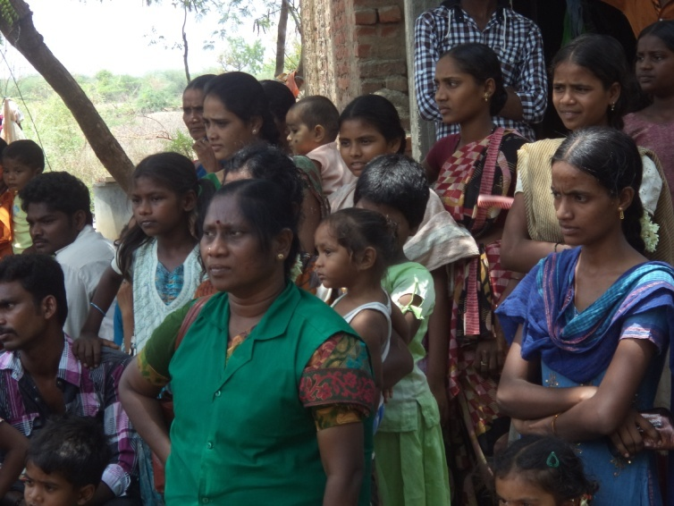
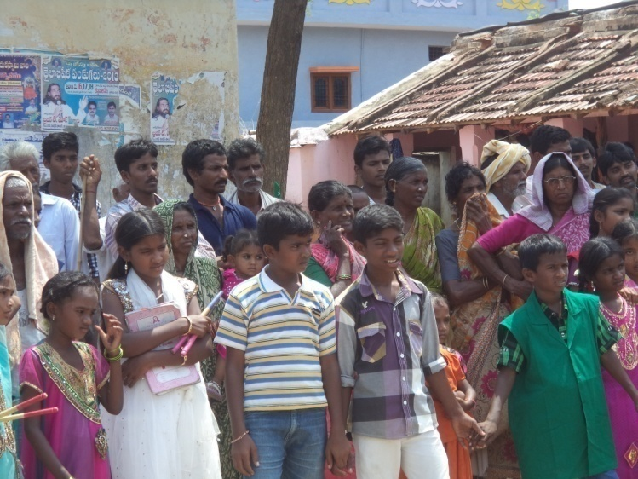

WORLD ENVIRIONMENT DAY – 5TH JUNE 2013
INTRODUCTION:

Rapid environmental changes cause extinctions of many species, natural resources such as land, forest, water, environment becoming scarce day by day as people tend to harm it and creating scarce for the future generations. Forest is the major resource for the livelihood of rural populace and for the environment protection, due to poverty deforestation taking place at all levels as the communities utilizing the natural resources. Children being citizens mobilize themselves to protect the environment by creating awareness among general population on ‘world environment day’ by organizing various programs. Children from ‘Balakeerthi’ project committed themselves to create awareness with support of HOTHS and KNH.
Covered by 3 Villages (Basinenipalli, kothapet, M.P.Cheruvu Children’s):-
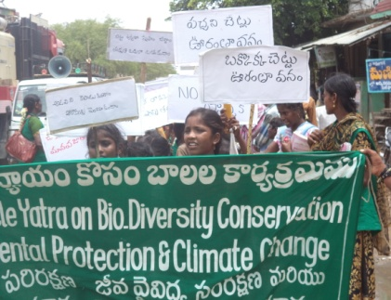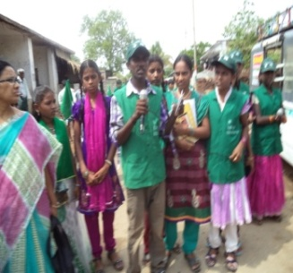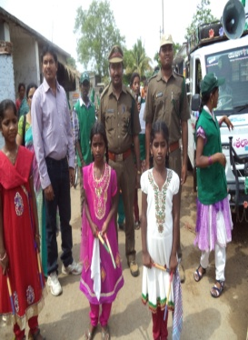
PLANNING:

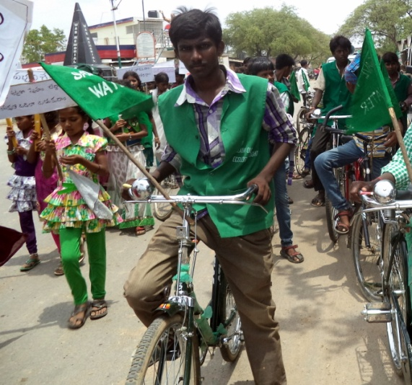
HOTHS organization has observing World Environment Day every year, for the year 2013 with a theme ‘Think, Eat and Save’. The children recognized that children are the first and foremost victims for any devastation whether it is sudden or long term, and they also learned that many children are dying from hunger and living with half empty stomach. Hence, HOTHS has meticulously planned to organize the event in a big manner, for the purpose, the consultations with children groups, cluster level associations and key stakeholders has been conducted and planned the event. During the planning meeting, the children and CLA members shared their ideas to create awareness with cycle rally, dance drama and messages. It was also discussed the items/materials to be procured, collection of resources, route map etc.,
CYCLE RALLY

‘Baalakeerthi’ project’s 37 Children group members gathered at ZP high school ground with cycles which are well decorated with green colour and green flag with messages on bio-diversity and environment.
- Route map: The route of the cycle rally from MP Cheruvu to Bestavarapet with 15 kms distance covering Kothapet, PT gulla JC.Agraharam.Mallapuram,and Kothapalli Villages. JC Agraharam children join at Pityakayagulla.

- Flagged off: Forest officer Shri.G.Raghunadhareddy inaugurated the cycle rally by flagging off. He addressed the hundreds of population including school children before he inaugurate the event. In his address he emphasized that ‘children are one of the major communication tool’ to change the behaviour and attitude of the parents and community’. He expressed his happiness for organizing the awareness rally in the remote rural areas; he thanked the HOTHS organization and KNH for its uninterrupted services to the needy children over the decade and their contribution in creating awareness on environment and bio-diversity. 18 boys and 19 girls in two different rows peddles their cycles by shouding slogans on protection on environment, Minivan which is well decorated with banners, placards with environment messages accompanied throughout the rally. 17 children from cultural team with green dress performed skit just before the start of the cycle rally.

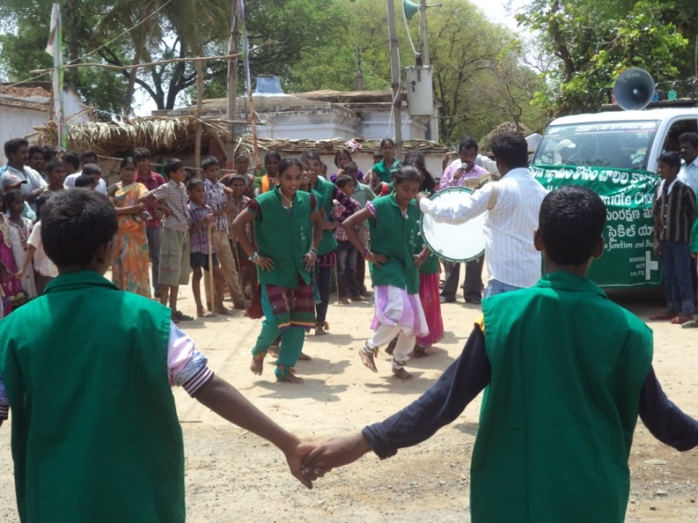
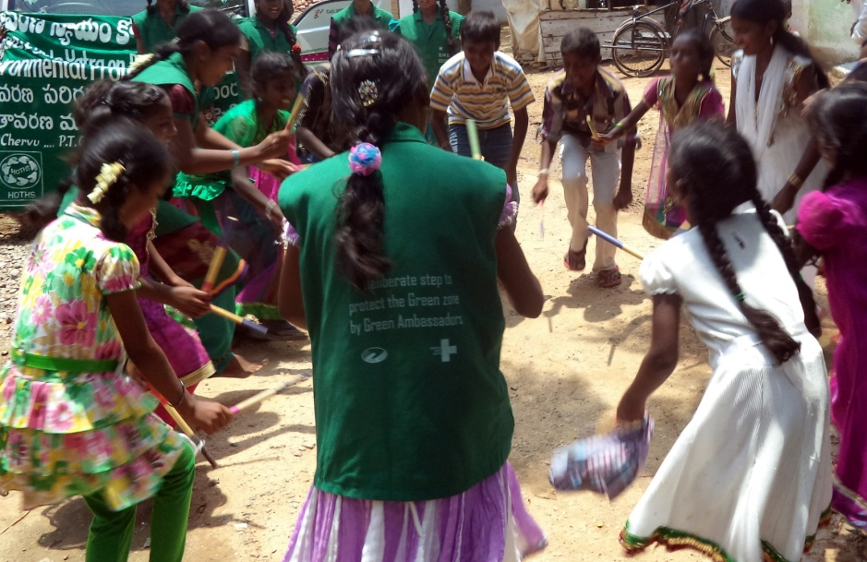
- Kolatam Dance: ‘Baalkeerthi’ project created a cultural dance team among the Children Groups in the project area. With learned skills, girls and boys performed Kolatam dance during the cycle rally where it has stopped at prominent places including village pockets. Many villagers (onlookers) witnessed the event and noted the messages on bio-diversity and environment.

- Dance drama (street skit): Cultural team members performed dance drama in the streets of prominent locations with theme on bio-diversity and environment, the skit includes role of each and every individual to protect the nature. HOTHS staff being a supportive team for cultural team with Dappu encouraged the children by playing varies level of music.

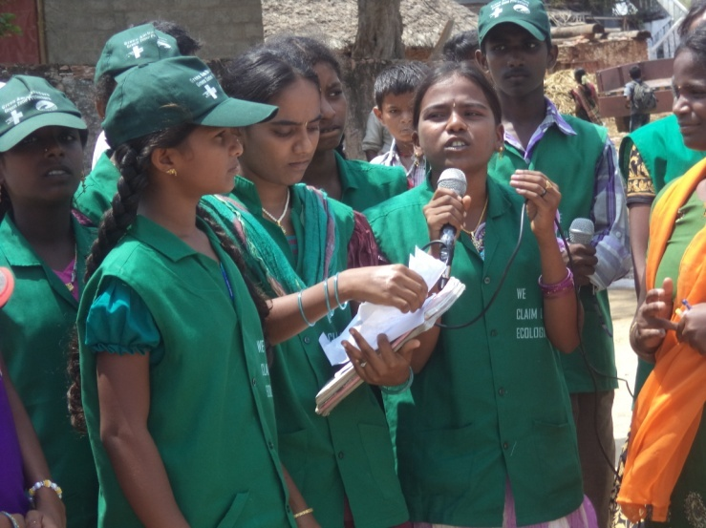
MESSAGE BY CHILDREN

Child Ambassadors and other Child Group leaders addressed the gathering soon after the dance drama at each location. Hundreds of villagers witnessed the event and with great interest they’ve listened the message on environment and bio-diversity. 10 child speakers addressed the gathering with innovative messages.
54 Children of Children Movement for Climate Justice (CMCJ) from 12 children groups from the project actively supported the child speakers. 50 youth from 25 villages involved and encouraged the child speakers.
MESSAGE BY DIGNITARIES

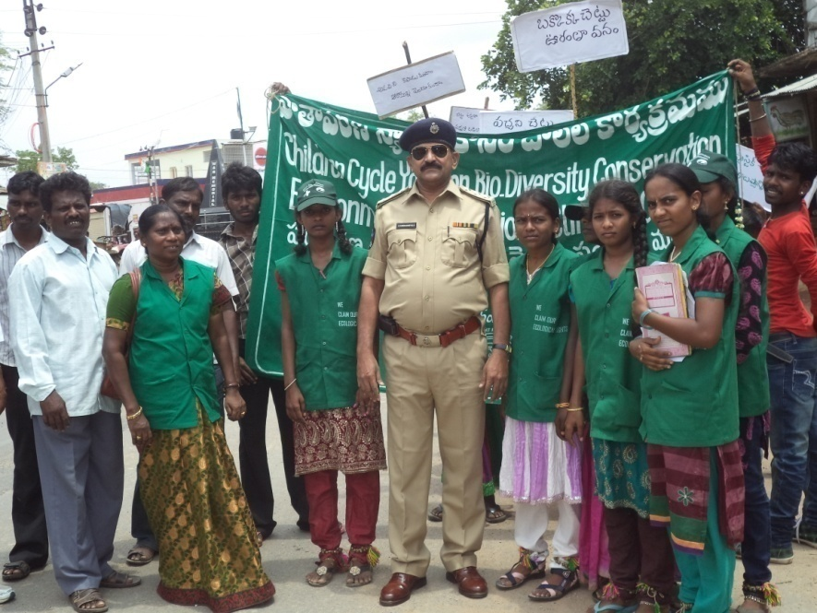
Dignitaries from police, forest, health and education department actively participated in the event.
- Deputy Superintendent of Police DSP: Shri. Ramanjaneyulu, DSP supported the event by participating in the rally and addressed the gathering. He encouraged the children and audience and also appreciated HOTHS initiatives and requests them to continue such event in the future also.

- Medical Officer: Dr. Chandra Sekhar, medical officer of PHC Garlzaragulla addressed the gathering and informed about them that protection of environment is very crucial and everyone should play their role and they should learn from children as they are educating adults. Good environment contributes for good health, villager need to protect themselves and their children. He thanked the organizers of HOTHS for making everyone to be aware of bio-diversity and environment.

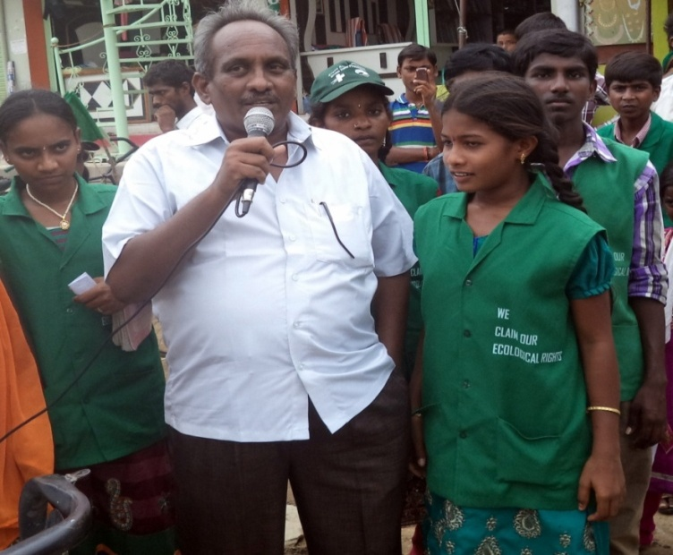
- Mandal Education Officer (MEO): Shri. Madava Krishna Mandal Education Officer of Besthavaripet participated and addressed the gathering by stating that as part of education program all the school children should learn about current events and need to protect the environment. He made an appeal to everyone that education is vital to for growth and development and it plays important role in the well being of individual, family and state. He thanked the HOTHS for inviting him to this event.

CONCLUSION

5th June 2013 is memorable event to the many children, especially CMCJ members, CLA members as they’ve witnessed the response and support from the community. Many villagers contributed cycles, 50 youth prepared placards and wrote slogans on the cards, CMCJ members and project staff prepared flags and children decorated cycles, minivan was decorated with slogans and audio system to address the gathering was maintained by the youth. More than 1500 people witnessed and received awareness messages on bio-diversity and protection of environment. Local media covered the event and print news papers contributed by covering the event. The total event was possible because of local financial contribution from individuals.

